# Mechanical Structure

If temperature of room increases then, we have this as input. It causes to change in the temperature of room, so the input is because of natural cause and is measured by LDR.

To change temperature of room when it increases/decreases above limit, we will use two functions.

1. That increases temperature
2. That decrease temperature

## Function that increase temperature

Using a rod that heats up the isolated system and increases its temperature.

## Function that Decreases Temperature

Using Joules Thomson effect we can compress air and then expand it, this causes increase in temperature.

# Electrical Structure

## General Diagram

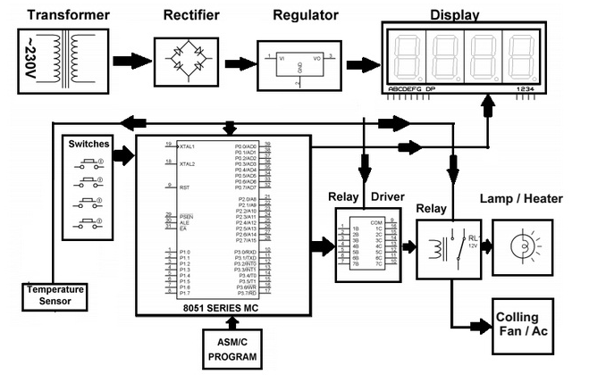

## Temperature Control

We can use LM335 as a temperature sensor to attach it with Arduino.

The temperature board is attached with an Arduino, USB Input/output controller. Temperature sensor takes an input of 5v, and will output a voltage at +10 mV/ Kelvin, and this unit of temperature can be easily converted to Celsius. The temperature data switch devices, sound alarms, etc., which will get incorporated to an input/output board.

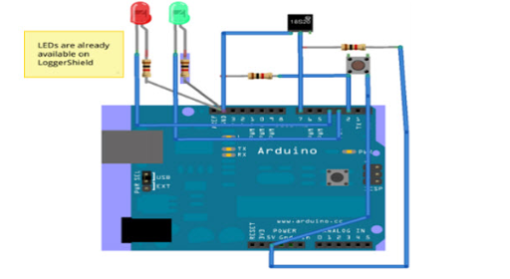

### How to Do

To do this we need to code in Arduino by applying 5V to sensor and attach an LCD with Arduino so that it shows the result on LCD w.r.t 5mV signal / Kelvin.

It’s 1.706 x 10-3per 20 degree Celsius, so we can easily set limit in programming.

## Display

As, said above we need to turn on display using Arduino control. This can be done simply by using that basic [link](https://www.arduino.cc/en/Tutorial/HelloWorld) of Arduino control.

Other things, like sub-functions can be simply add by coding logics.

## Used Components

We used the following components to design the circuit model:

1. Two way switch
2. Arduino UNO
3. Breadboard
4. Potentiometer (0-100kΩ)
5. Resistors (2kΩ & 220Ω)
6. LCD (16,2) 🡪 JHD162A
7. Temperature sensor 🡪 LM335
8. Amplifier 🡪 LM741
9. Motion Sensor
10. AND Gate IC 🡪 7408
11. Fan (In figure it’s represented by LED attached to pin 8 of Arduino)
12. Heater (In figure it’s represented by LED attached to pin 9 of Arduino)
13. Wires (M-M & M-F)
14. Breadboard

## Details

The model is represented in figure 6, which is drawn on Fritzing. It shows an LCD which is connected with Arduino and share data via 4 data pins. Also, we have 5V supply at the terminal line of breadboard. All the operations are performing on these 5V. The temperature sensor LM335 is used to measure atmospheric temperature. We have the potentiometer to vary the contrast of LCD, the resistance of potentiometer ranges to 100Ω, and is connected to the third pin (V0) of LCD. In this model the two LEDs are the representation of heater and fan, which turns on when error occurs. The way switch is used to switch between time and temperature. Here, schematics and breadboard model are given below:

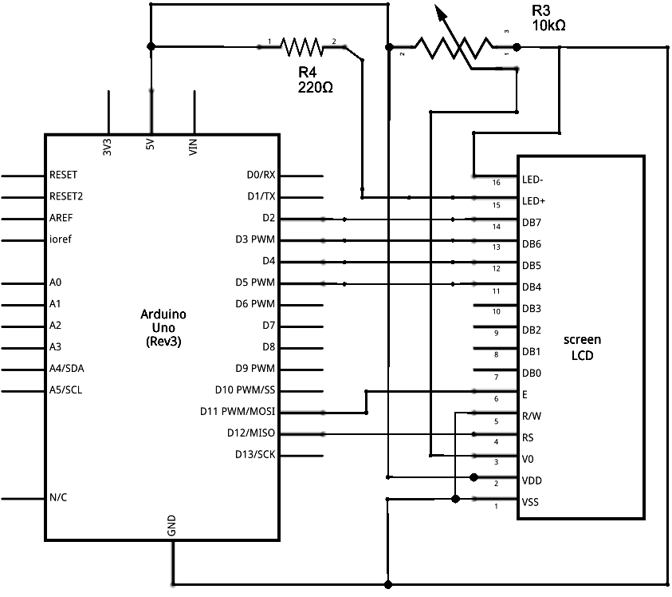

Figure 7: Schematics

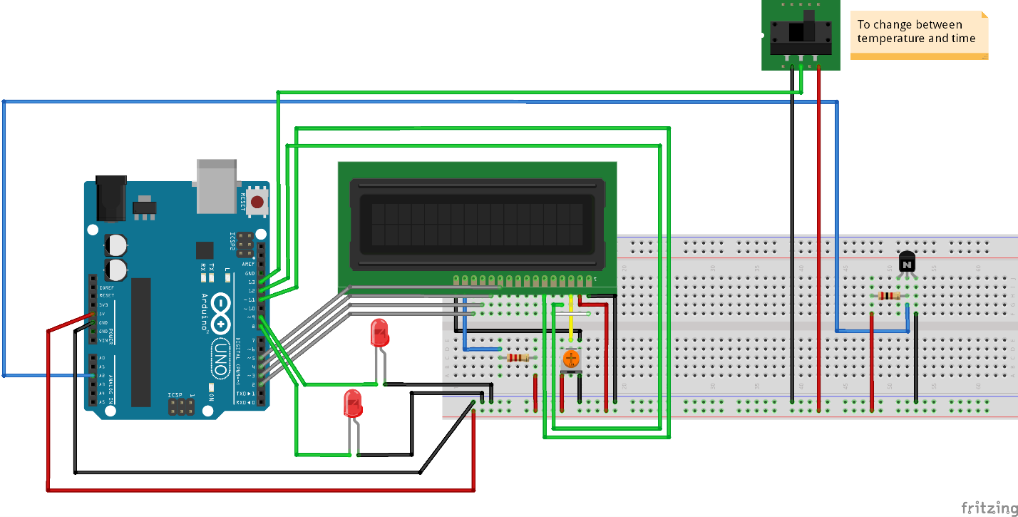

Figure 8: Circuit model

## Model Designing of Extrenal Circuit

For the external circuit we need to take a motion sensor, and a ‘AND’ gate and an amplifier. By simply connection of amplifier with 12V relay and then to the heater we can easily perform work. Here, we have the proteus diagram.

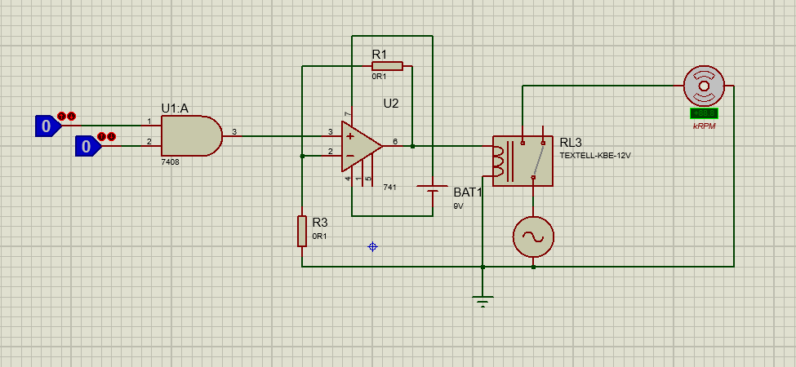

Figure 9: Proteus Amplifier circuit

We used this circuit to use components at high voltage, like practical heater and compressor. However we not attached this in project, but one can easily attach compressor or heater or both with terminals leaving. In above diagram we attached a fan. In our practical circuit these terminals are opened.

The PCD Design of that circuit is given below:

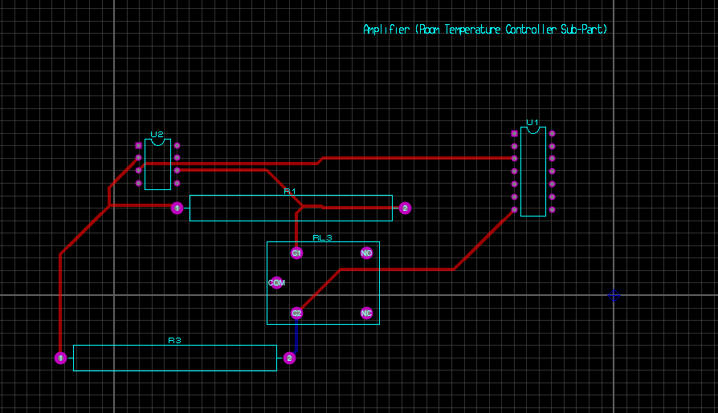

Figure 10: PCB of amplifier circuit